Materials

* Electronic Parts
  + Arduino
    - Circuit board
    - Jumper wires
  + Sensors
    - CO2 sensor
    - Pressure sensor (?)
    - Flow meter (?)
* Mechanical Parts
  + Ventilation Tubing
  + Filters (bacterial and viral)
  + Pressure valve
  + PEEP valve
* Testing
  + Balloon (“Lung”)

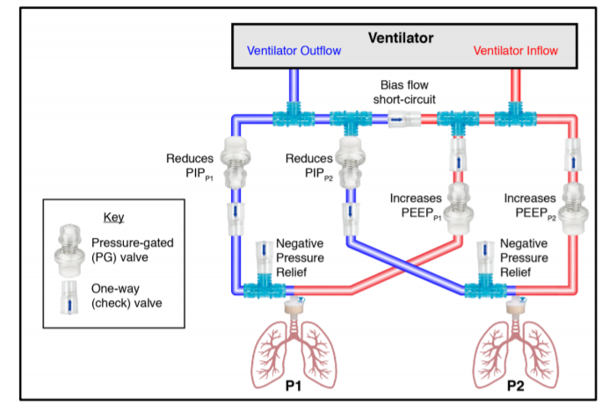

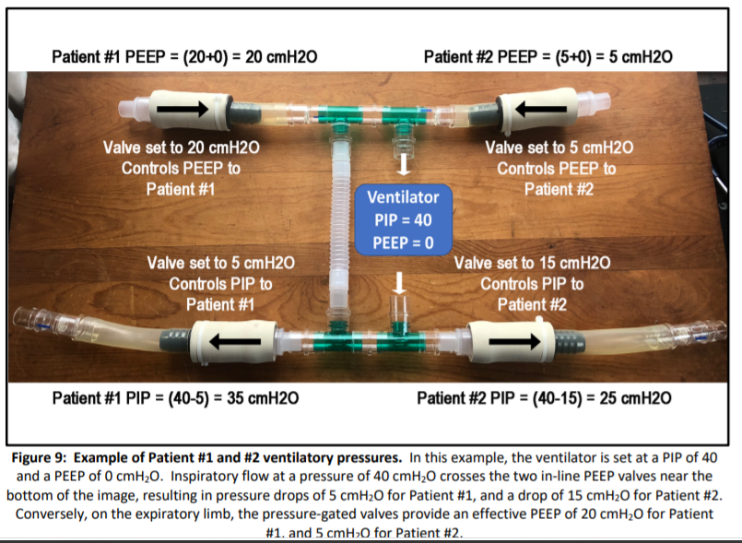

Notable Characteristics:

* **Inspiratory and end-expiratory pressures** for each patient can be **titrated over time, without** changes for one patient affecting the ventilation parameters of the other patient.
* Using **in-line spirometry**, individual **tidal volumes** can be measured for each patient.
* Two (or more) patients may be ventilated using a single contemporary ICU ventilator, or using a single contemporary operating room anesthesia machine
* PIP and PEEP are individualized for each patient
* PIP and PEEP can be adjusted for each patient over time, as lung compliance changes
* Valves minimize cross-patient ventilation, even in extreme circumstances such as chest compressions
* Compatible with bacterial and viral filters to minimize infectious cross-contamination
* Compatible with individualized **real-time patient spirometry** and airway **manometry**
* Made entirely from off-the-shelf components, no 3D printed or specialty parts needed

Functional Aspects and Limitations:

* Pressure-control ventilation mode is optimal and assumed for this design
* **Pressure readouts** on the ventilator screen reflect unmodified pressures delivered by the ventilator, and **are not representative of what each patient is seeing**
* **PIP and PEEP** for each patient are obtained by **adding/subtracting** each **patient’s valve settings** from displayed ventilator settings – see below
* **Tidal volume readout** on the ventilator is **total tidal volume** for both patients
* Additional monitors may be deployed in-line for each patient, to measure tidal volumes and airway pressures individually and in real time
* FIO2 and respiratory rate are the same for both patients
* Tidal volumes will differ for each patient, depending on PIP, PEEP and lung compliance
* A **short circuit** from the ventilator outflow to ventilator inflow is necessary to avoid triggering of circuit occlusion alarm and to allow ventilator bias flow
* Because of changes to the expected circuit, ventilator alarms will not always work as expected, and an **alternate alarm strategy must be employed** (see discussion below)

Proposed Alarm Settings:

· Shared VTe: Low alarm = Shared VTe – 50 ml, High alarm = Shared VTe + 50 ml, alarm set to trigger if 2 breaths are outside of this range

· Individual VTe (if available): Low alarm = VTe – 50 ml, High alarm = VTe + 50 ml

· Ventilator Ve: Low alarm = Ve – 1 L, High alarm = Ve + 1 L

· Ventilator RR: Low alarm = RR – 3 bpm, High alarm = RR + 3 bpm

· PIP alarm (if available): Low alarm = Set PIP – 5 cmH2O, High alarm = Set PIP + 5 cmH2O

· PEEP alarm (if available): Low alarm = Set PEEP – 2 cmH2O, High alarm = Set PIP + 5 cmH2O

· ETCO2 alarm (if available): Low alarm = Target ETCO2 – 5 mmHg, High alarm = Target ETCO2 + 5 mmHg